**Spcm lab 1**

### Download Terraform File for Windows

To find the latest version of Terraform for Windows:

1. Browse to the [Download Terraform](https://developer.hashicorp.com/terraform/downloads) page.

2. Select the Windows tab under the **Operating System** heading. The latest version is preselected.

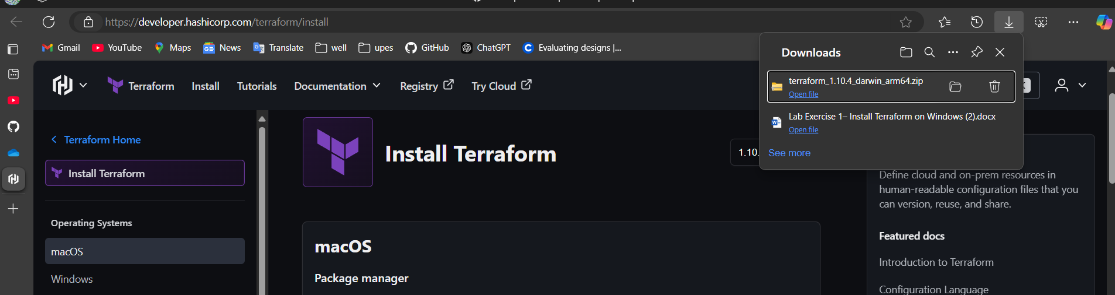

3. Choose the binary to download. Select 386 for 32-bit systems or [AMD64](https://phoenixnap.com/glossary/amd64) for 64-bit systems. Choose the download location for the zip file if the download does not start automatically.

4. Unzip the downloaded file. For example, use the *C:\terraform* path. Remember this location so you can add the path to the environment variables.

### Add Terraform Path to System Environment Variables

To add the Terraform executable to the system's global path:

1. Open the start menu, start typing *environment* and click **Edit system environment variables**. The System Properties window opens.

2. Click the **Environment Variables...** button

